**21CY682-SECURE CODING LAB**

**SET USER ID : LAB 6**

**NAME :RAMYA AJAY**

**ROLL NO:CB.EN.P2CYS22004 DATE:26-10-2022**

**1. Figure out why "passwd", "chsh", "su", and "sudo" commands need to be Set-UID programs. What will happen if they are not? If you are not familiar with these programs, you should first learn what they can do by reading their manuals. Please copy these commands to your own directory; the copies will not be Set-UID programs. Run the copied programs, and observe what happens.**

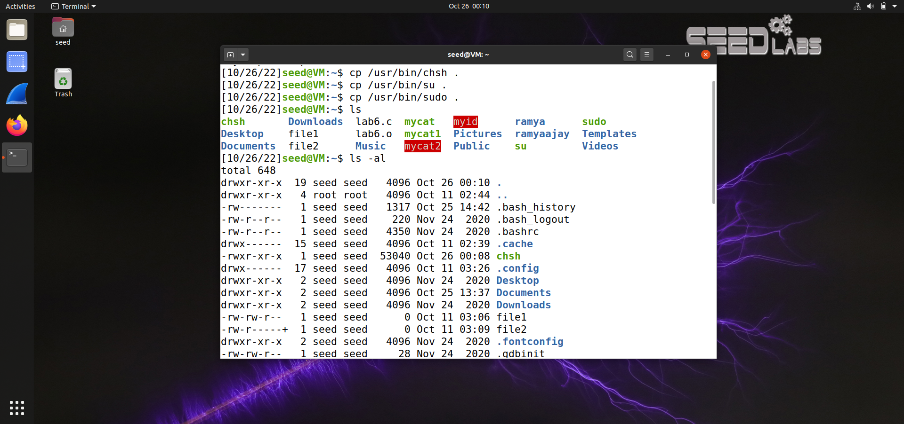

When we copy these SUID binaries from /usr/bin directory to our user’s directory the SUID bit gets stripped off. This is a security mechanism to prevent privilege escalation and other attacks which may cause the whole system accounts to be compromised.

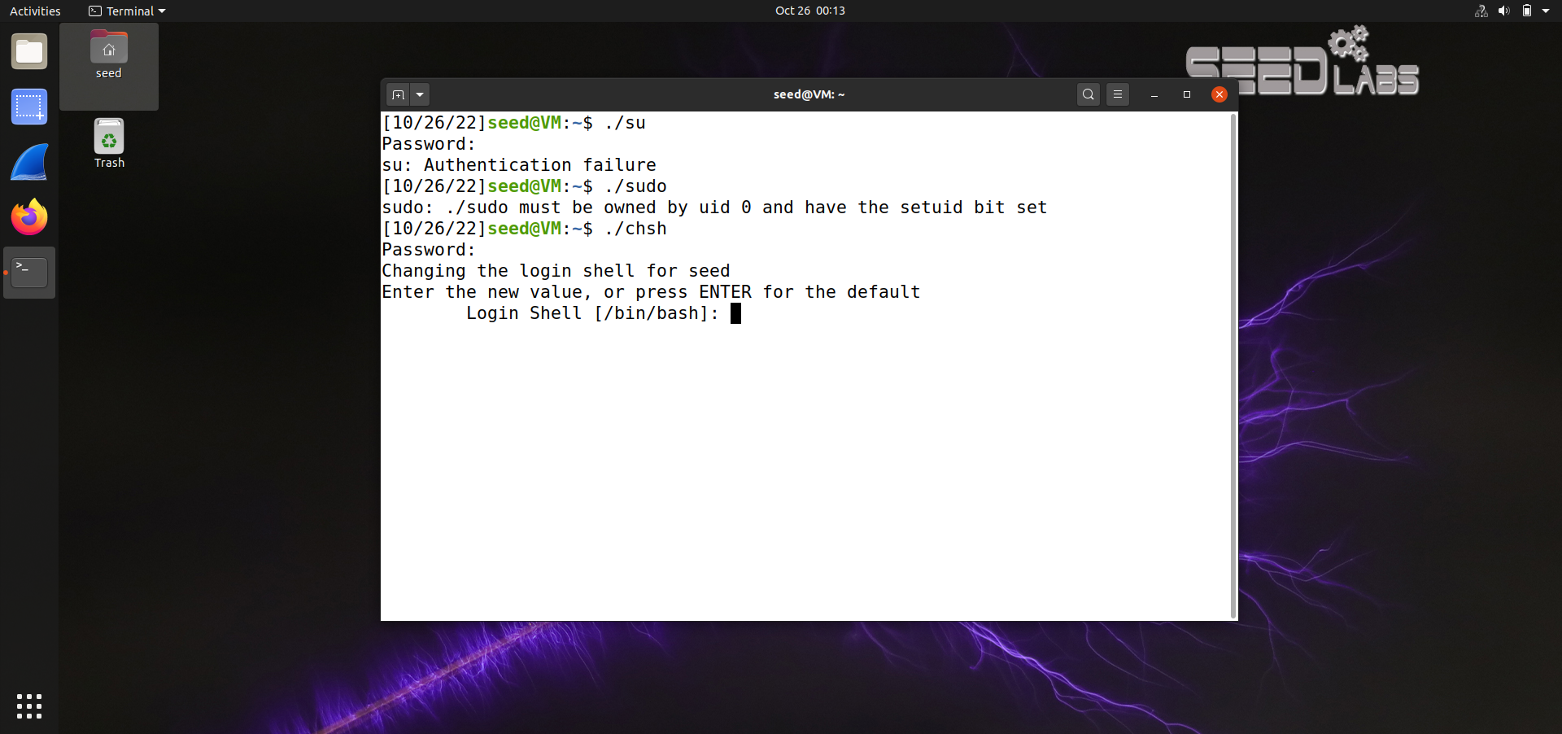

We can see from the above screenshot that we are not able to run those binaries since it needs to be run as root. Incase of passwd binary , we are able to change the password of the current user only and not the root user since the suid bit is removed.

**2. Run Set-UID shell programs in Linux, and describe and explain your observations.**

**a) Login as root, copy /bin/zsh to /tmp, and make it a set-root-uid program with permission 4755. Then login as a normal user, and run /tmp/zsh. Will you get root privilege? Please describe your observation.**

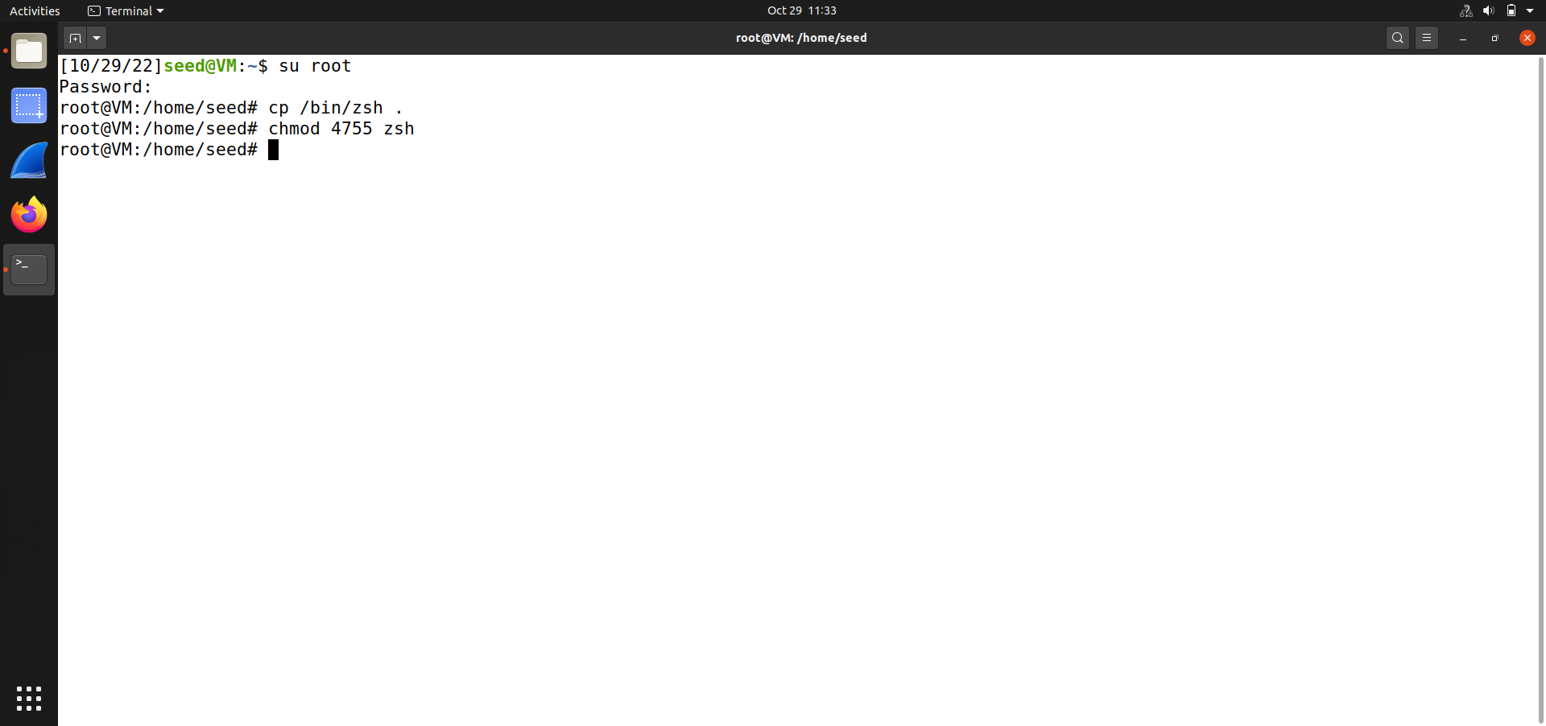

We log in as root user and after copying /bin/zsh binary to /tmp folder , we give setuid bit to it.

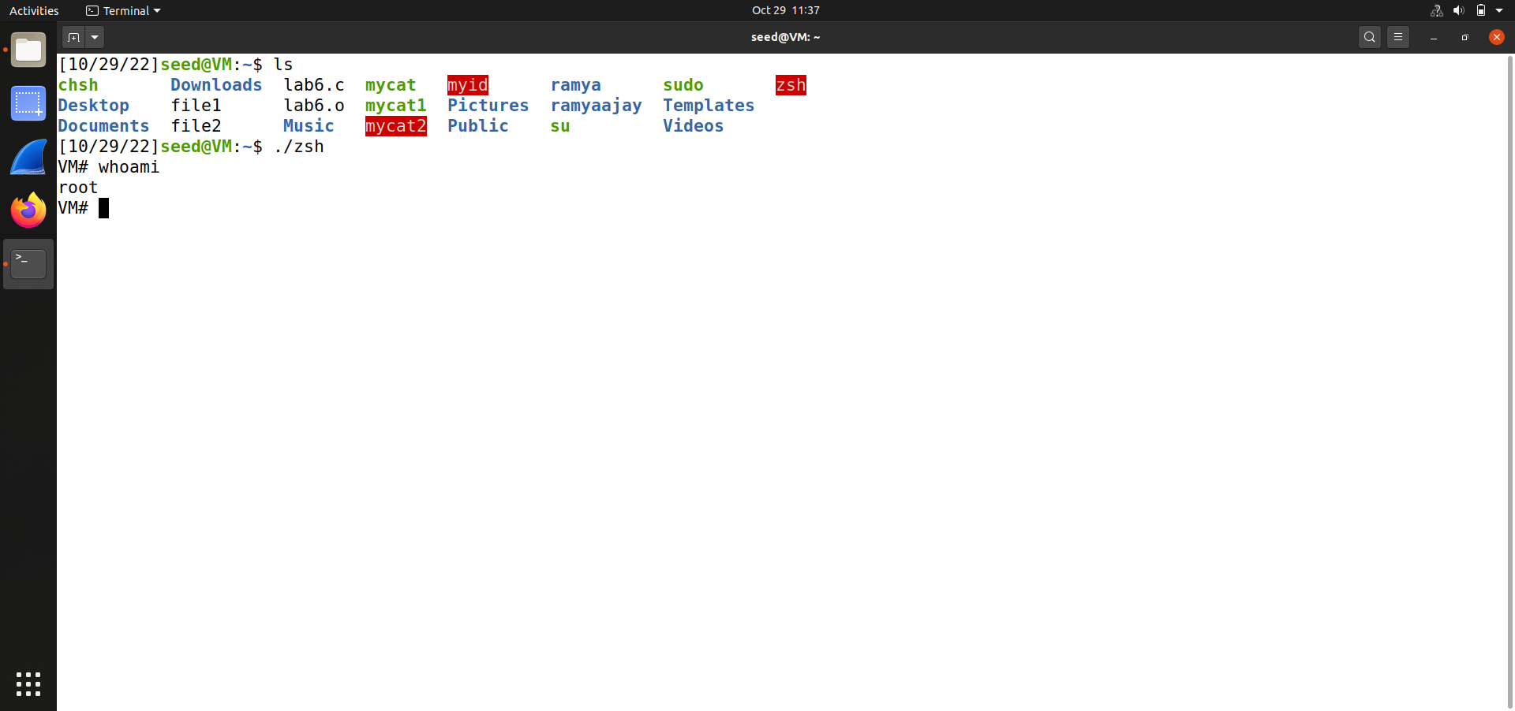

Now when we run the zsh binary as normal user we get a shell as root !

**b) Instead of copying /bin/zsh, this time, copy /bin/bash to /tmp, make it a set-root-uid program. Run /tmp/bash as a normal user. will you get root privilege? Please describe and explain your observation.**

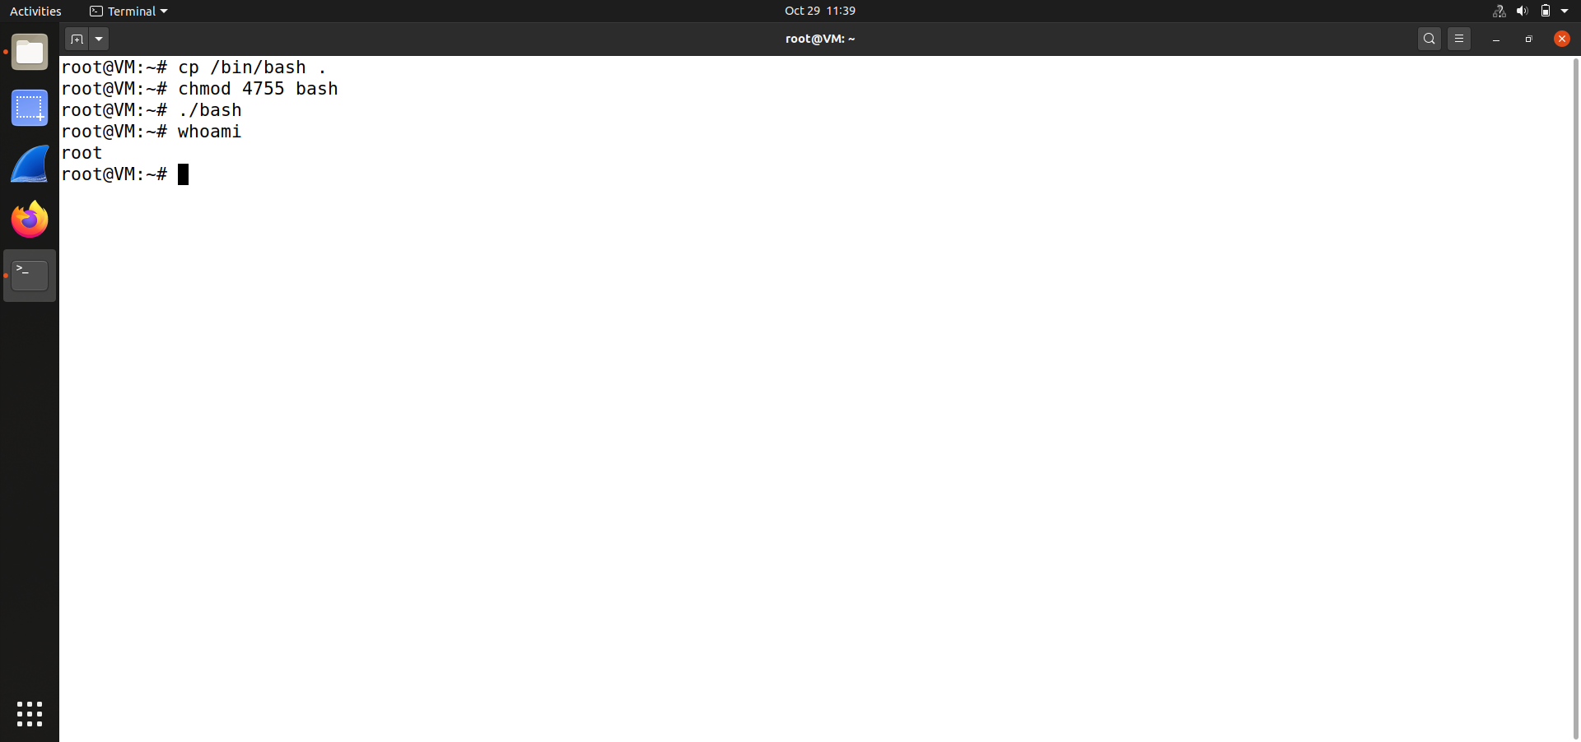

But when we give setuid permission to bash binary which we copied to /tmp directory as root & when we run the bash binary as normal user we don’t get a root shell. Some built-in security mechanism takes place here in bash binary.

**3. As you can find out from the previous task, /bin/bash has certain built-in protection that prevent the abuse of the Set-UID mechanism. To see the life before such a protection scheme was implemented, we are going to use a different shell program called /bin/zsh. In some Linux distributions (such as Fedora and Ubuntu), /bin/sh is actually a symbolic link to /bin/bash. To use zsh, we need to link /bin/sh to /bin/zsh.**

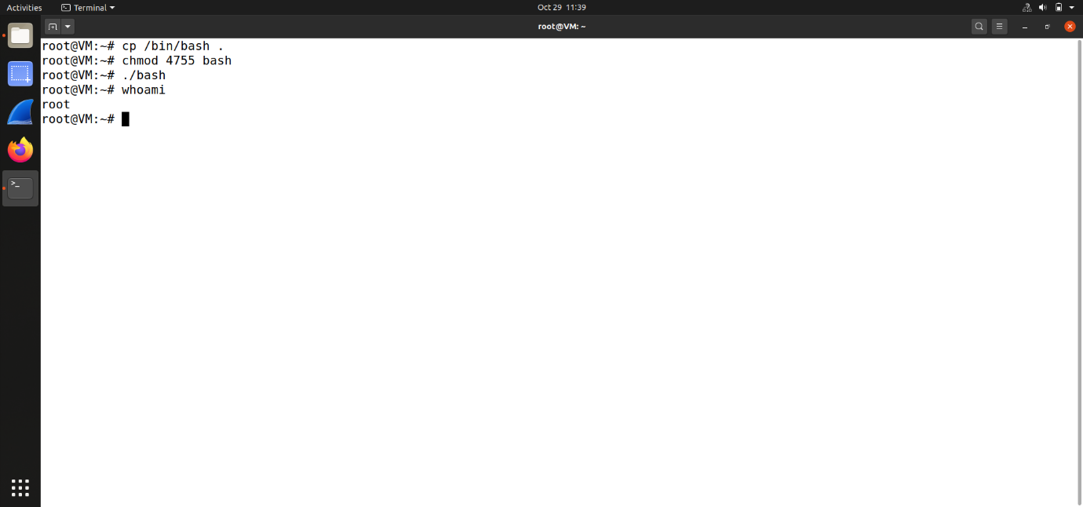

Here we first remove the sh binary from the /bin binary. Then we create a soft link using ln command for sh. (Ie) sh points to zsh

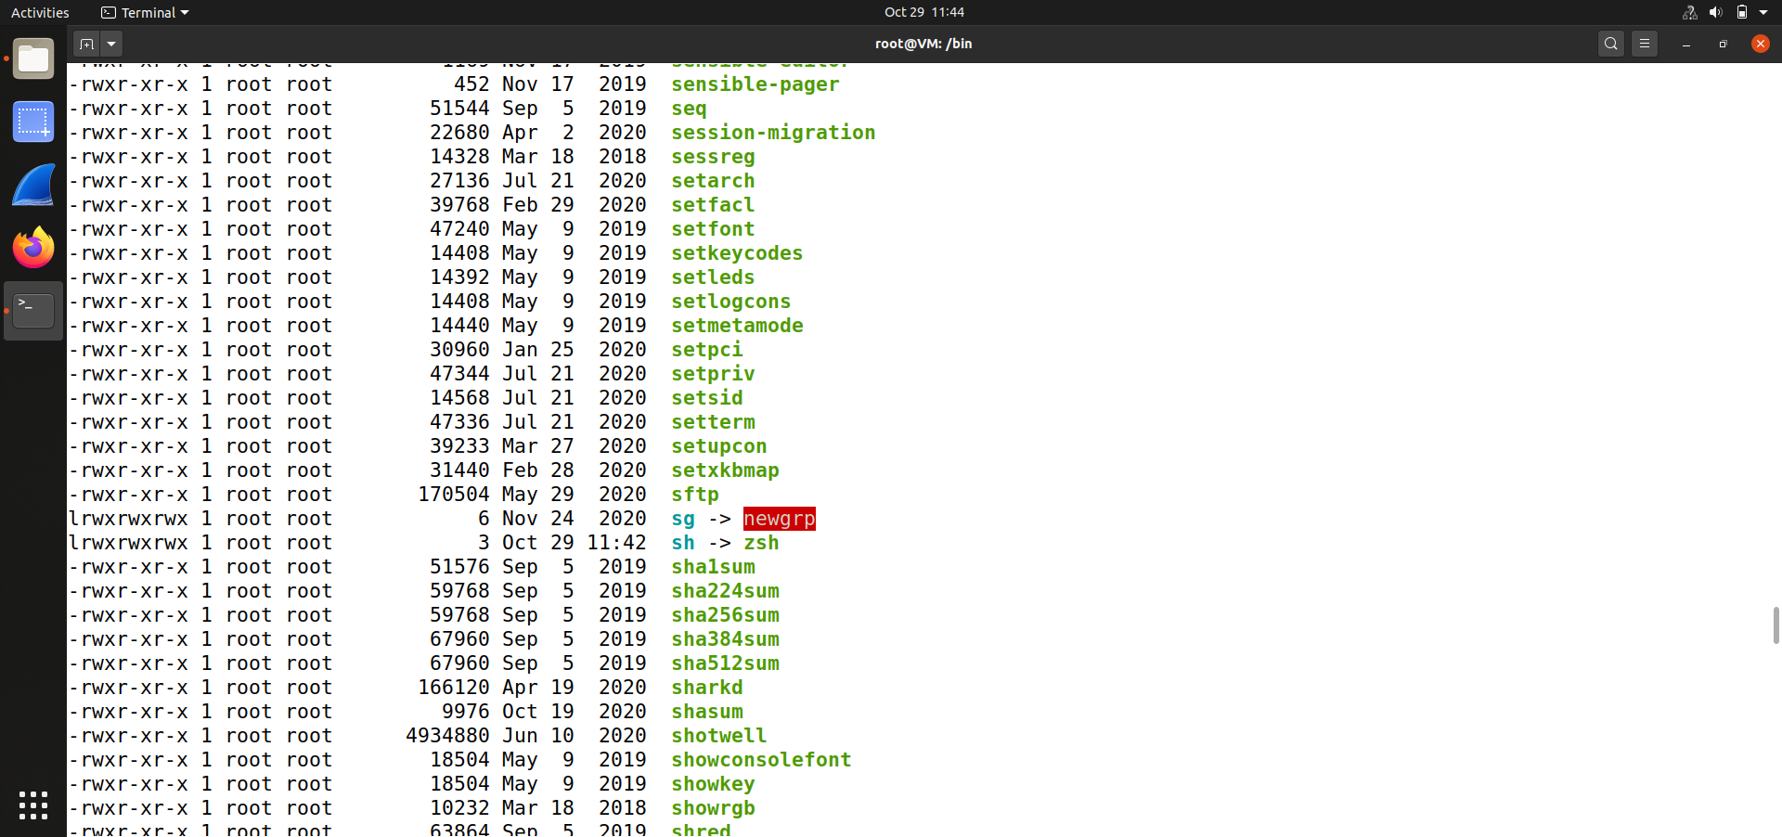

The arrow symbol indicates that a soft link has been created for the sh binary.

**4. The PATH environment variable.**

**The system(const char *cmd) library function can be used to execute a command within a program. The way system(cmd) works is to invoke the /bin/sh program, and then let the shell program to execute cmd. Because of the shell program invoked, calling system() within a Set-UID program is extremely dangerous. This is because the actual behavior of the shell program can be affected by environment variables, such as PATH; these environment variables are under user’s control. By changing these variables, malicious users can control the behavior of the Set-UID program. In bash, you can change the PATH environment variable in the following way (this example adds the directory /home/seed to the beginning of the PATH environment variable):**

**The Set-UID program below is supposed to execute the /bin/ls command; however, the pro- grammer only uses the relative path for the ls command, rather than the absolute path:**

**int main()**

**{**

**system("ls"); return 0;**

**}**

* 1. **Can you let this Set-UID program (owned by root) run your code instead of /bin/ls? If you can, is your code running with the root privilege? Describe and explain your observations.**

This program is a SUID program meaning it will run as root. So if we are able to copy the /bin/sh binary and rename it as ls and change the value of PATH variable to make the computer look for ls binary in the /root directory first then we can make the system to run our malicious ls binary which is in real a /bin/sh binary.

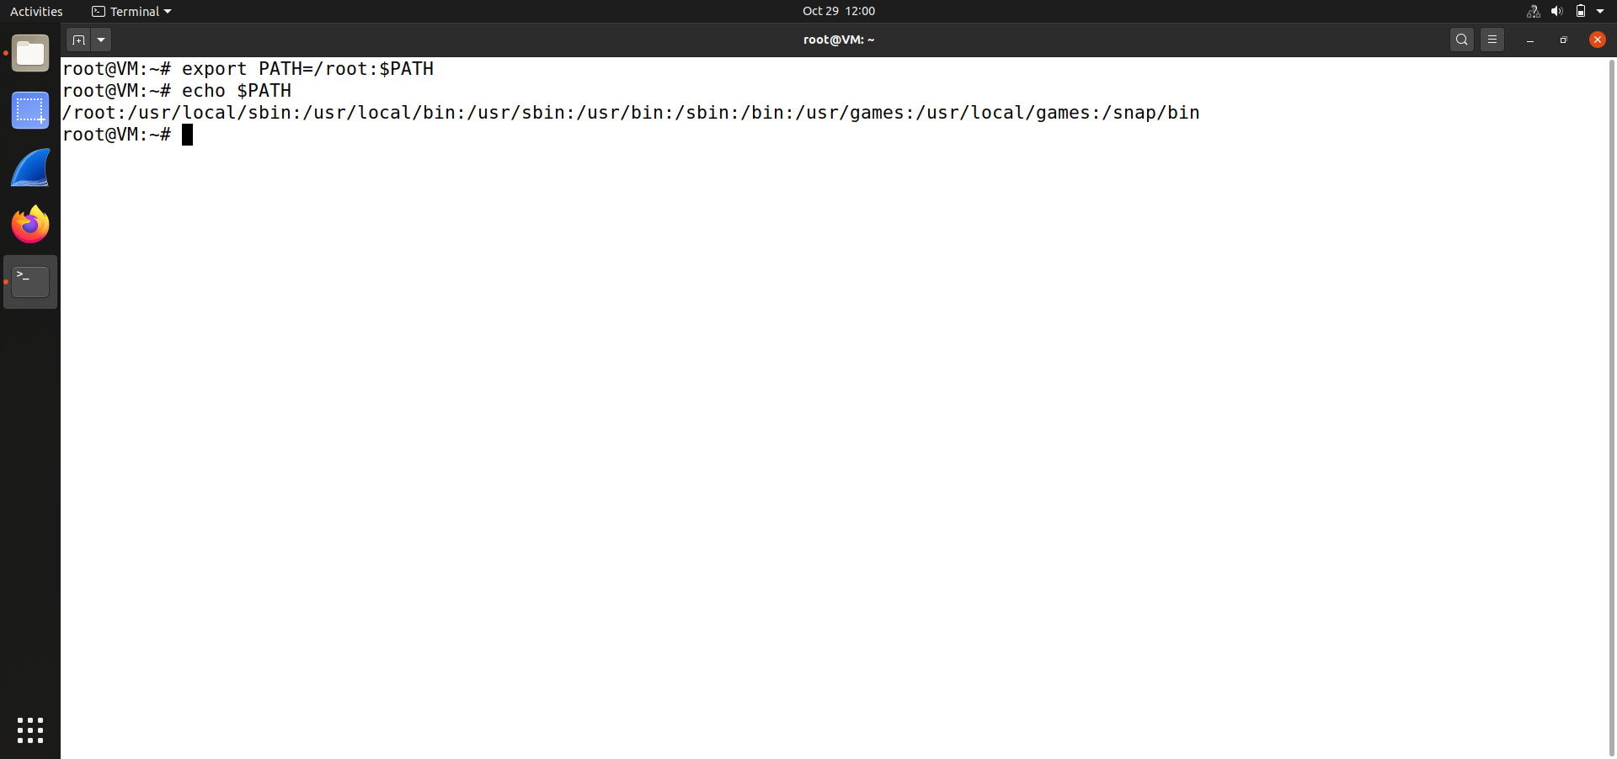

Here we have modified the PATH environmental variable.

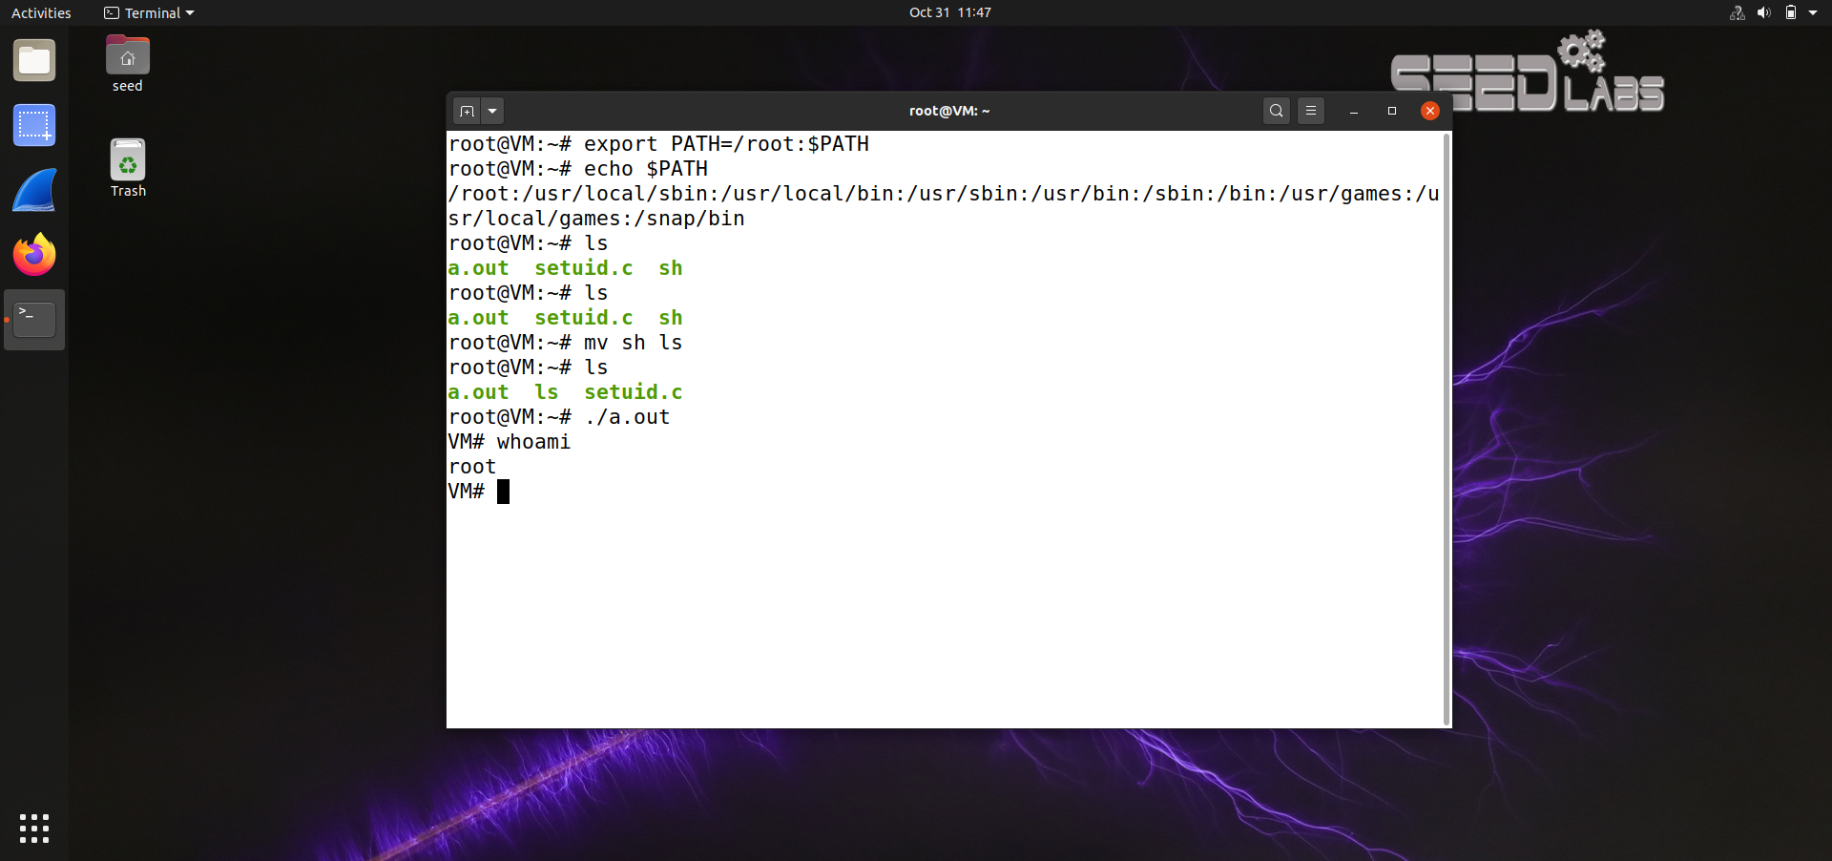

Now when we run the compiled program which has the Set-UID bit it runs the ls binary(/bin/sh) and gives us the root shell. Thus leading to escalation of privilege.

* 1. **Now, change /bin/sh so it points back to /bin/bash, and repeat the above attack. Can you still get the root privilege? Describe and explain your observations.**

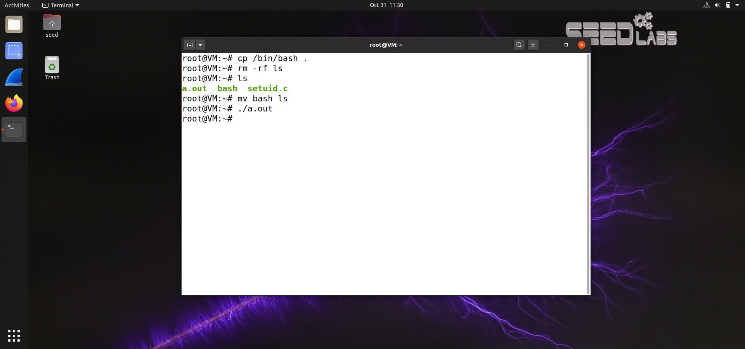

Now we replace the sh binary with bash and repeat the same process. But this time when we run the binary we do not get an elevated root shell since bash binary has some built in security mechanisms.

**5. The difference between system() and execve(). *Before you work on this task, please make sure that* /bin/sh *is pointed to* /bin/zsh.**

**Background: Bob works for an auditing agency, and he needs to investigate a company for a sus- pected fraud. For the investigation purpose, Bob needs to be able to read all the files in the company’s Unix system; on the other hand, to protect the integrity of the system, Bob should not be able to modify any file. To achieve this goal, Vince, the superuser of the system, wrote a special set-root-uid program (see below), and then gave the executable permission to Bob. This program requires Bob to type a file name at the command line, and then it will run /bin/cat to display the specified file.**

#include <string.h> #include <stdio.h> #include <stdlib.h>

int main(int argc, char *argv[])

{

char *v[3];

if(argc < 2) {

printf("Please type a file name.\n");

return 1;

}

v[0] = "/bin/cat"; v[1] = argv[1]; v[2] = 0;

/* Set q = 0 for Question a, and q = 1 for Question b */

int q = 0;

if (q == 0){

char *command = malloc(strlen(v[0]) + strlen(v[1]) + 2); sprintf(command, "%s %s", v[0], v[1]);

system(command);

}

else execve(v[0], v, 0);

return 0 ;

}

**Since the program is running as a root, it can display any file Bob specifies. However, since the pro- gram has no write operations, Vince is very sure that Bob cannot use this special program to modify any file.**

1. **Set *q* = 0 in the program. This way, the program will use system() to invoke the command. Is this program safe? If you were Bob, can you compromise the integrity of the system? For example, can you remove any file that is not writable to you? (Hint: remember that system() actually invokes /bin/sh, and then runs the command within the shell environment. We have tried the environment variable in the previous task; here let us try a different attack. Please pay attention to the special characters used in a normal shell environment).**

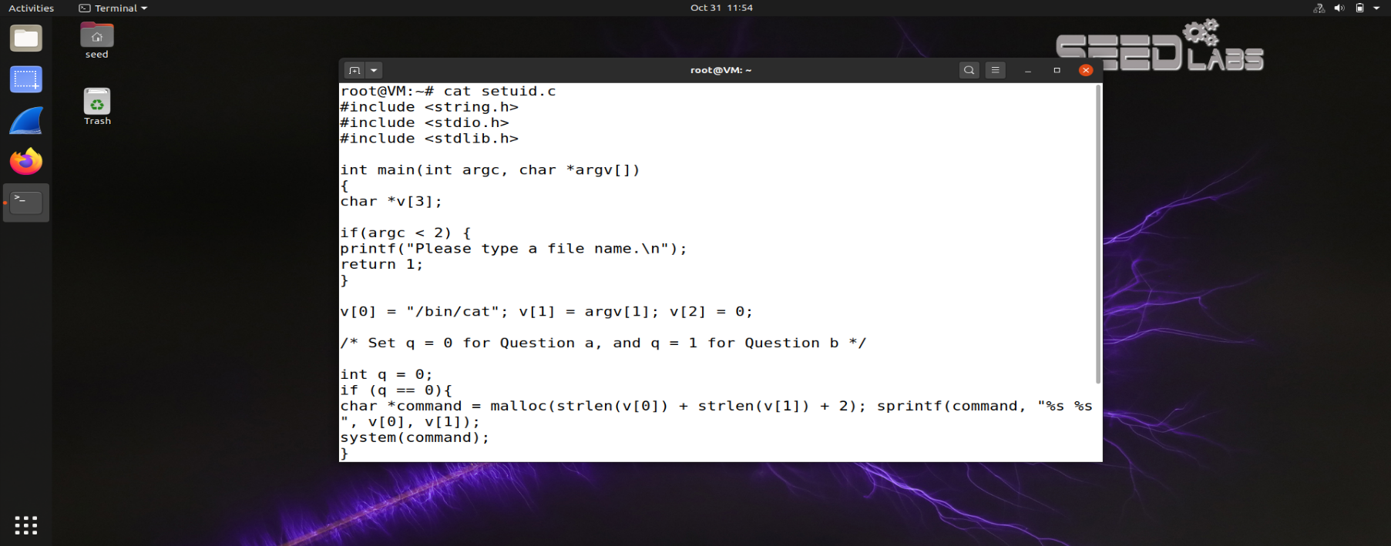

First we need to set the Q variable to 0 so that it invokes the system() function, then compile the program to get a binary.

After that we need to switch to the root account and give SUID permissons to the binary.

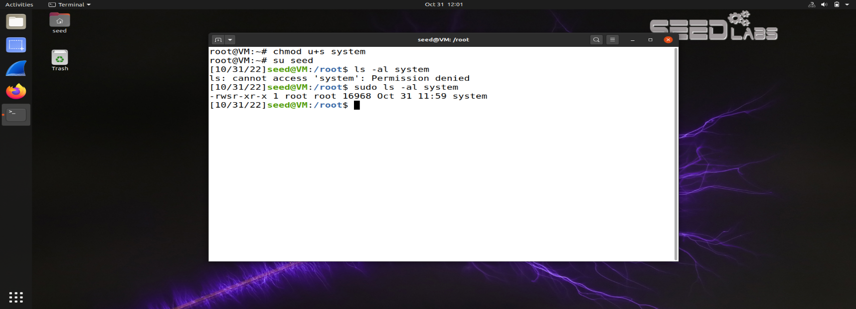

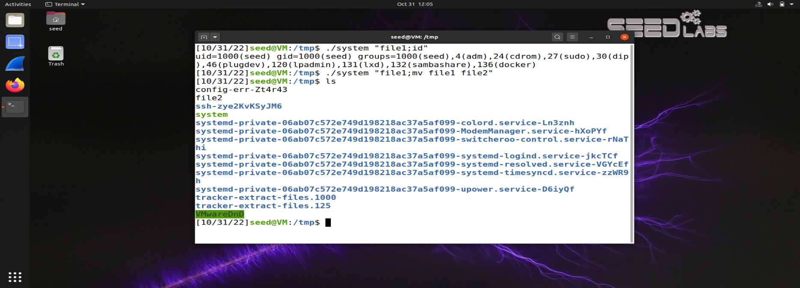

error

From the above we can see that, if we run the binary , it invokes the system function. The system() function invokes a shell to parse the string and handle quoting and variable interpolations . And so we were able to run other command like moving content of a file renaming etc which is very dangerous since the user can be able to modify any file of his wish.

1. **Set *q* = 1 in the program. This way, the program will use execve() to invoke the command. Do your attacks in task (a) still work? Please describe and explain your observations.**

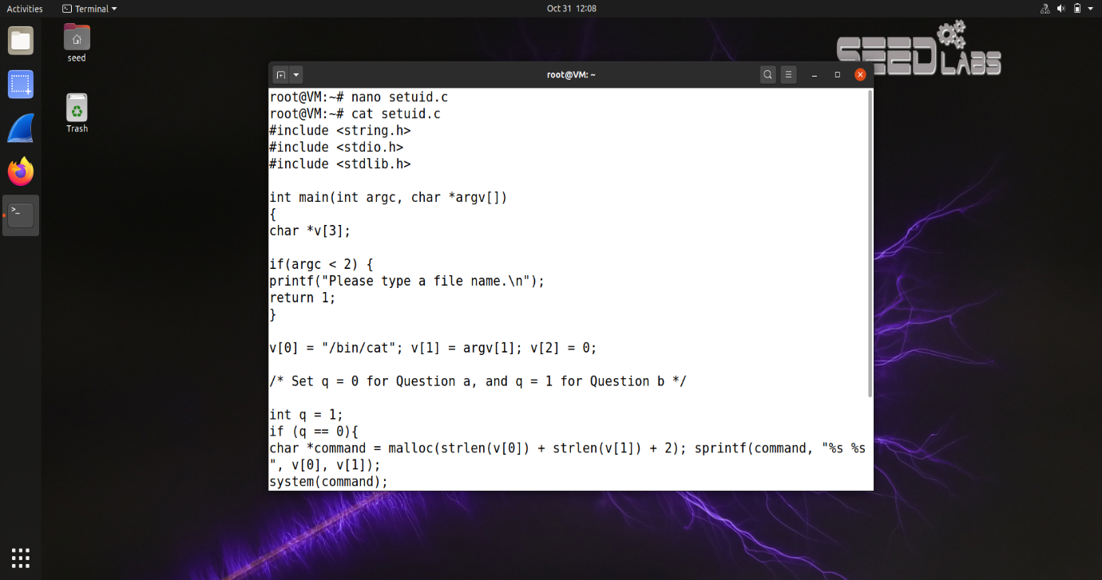

As per the program , if we set the q variable to 0 , it will invoke the execve() function.

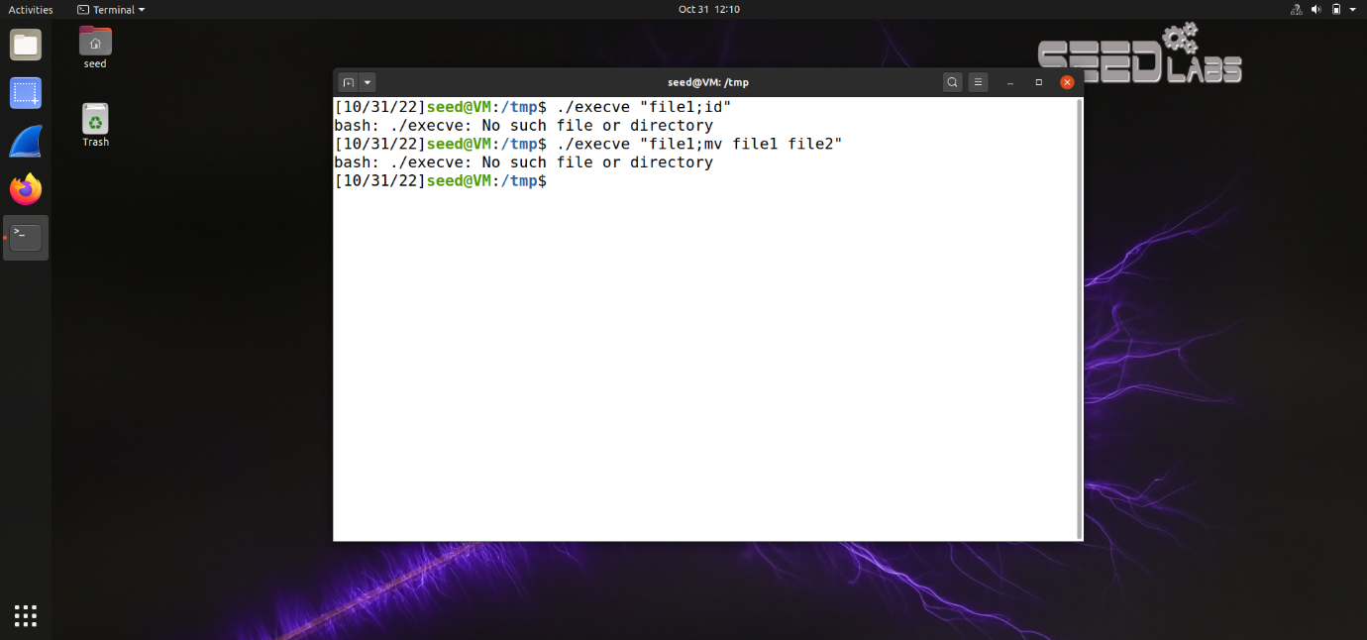

As we can see from the above image , while running the execve binary we get an error , this is because execve binary doesn’t invoke a shell to parse the string and handle quoting. So we cant run any commands within it.

Here the execve binary treats the entire stuff within the double quotes as string / folders and not as command.

**6. The LD PRELOAD environment variable.**

**To make sure Set-UID programs are safe from the manipulation of the LD PRELOAD environ- ment variable, the runtime linker (ld.so) will ignore this environment variable if the program is a Set-UID root program, except for some conditions. We will figure out what these conditions are in this task.**

**a) Let us build a dynamic link library. Create the following program, and name it mylib.c. It basically overrides the sleep() function in libc:**

**b) We can compile the above program using the following commands (in the -Wl argument, the third character is *l*, not one; in the -lc argment, the second character is *l*):**

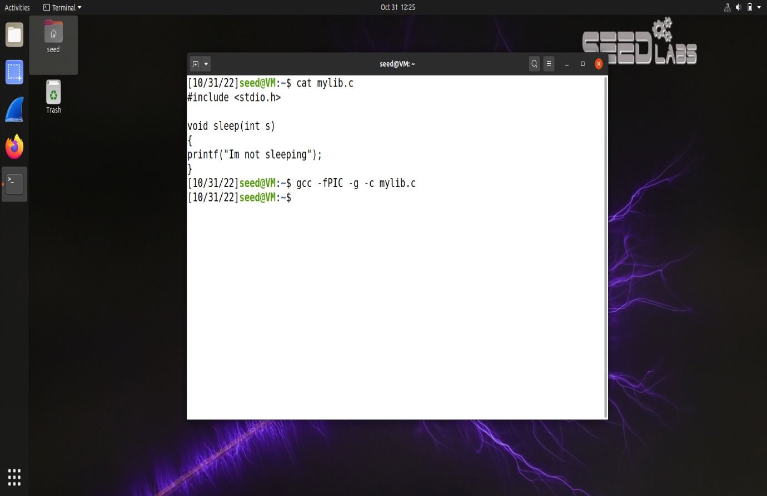

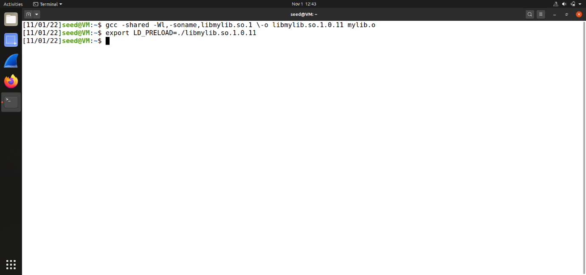

**c) Now, set the LD PRELOAD environment variable:**

**d) Finally, compile the following program myprog (put this program in the same directory as**

**Please run myprog under the following conditions, and observe what happens. Based on your ob- servations, tell us when the runtime linker will ignore the LD PRELOAD environment variable, and explain why.**

* **Make myprog a regular program, and run it as a normal user.**

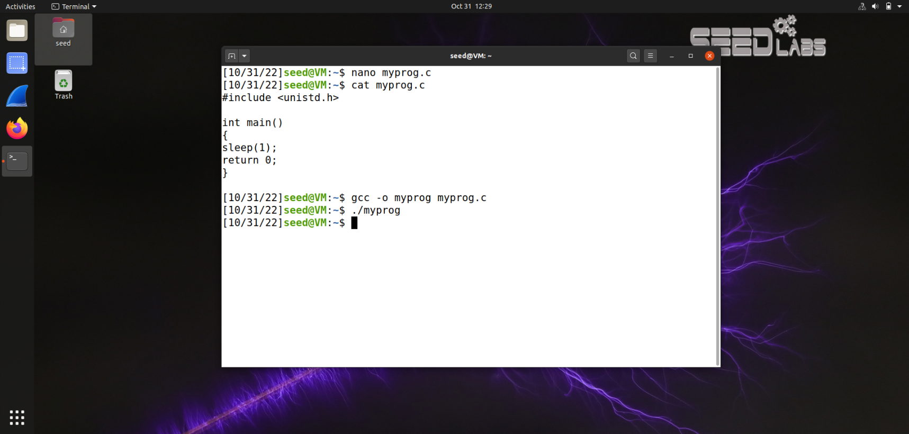

* **Make myprog Set-UID root program, and run it as a normal user.**

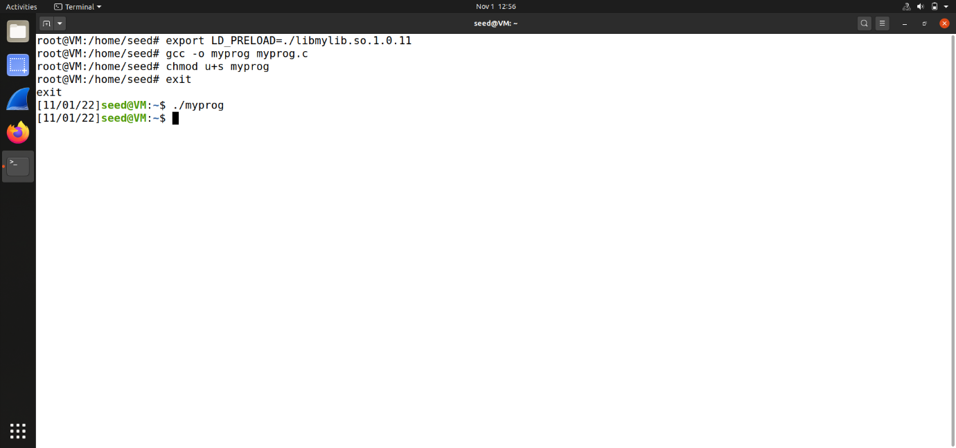

In this situation, it will ignore LD_PRELOAD environment variable and use the system's default sleep() function. So sleep() function will not be overrided.

* **Make myprog a Set-UID root program, and run it in the root account.**

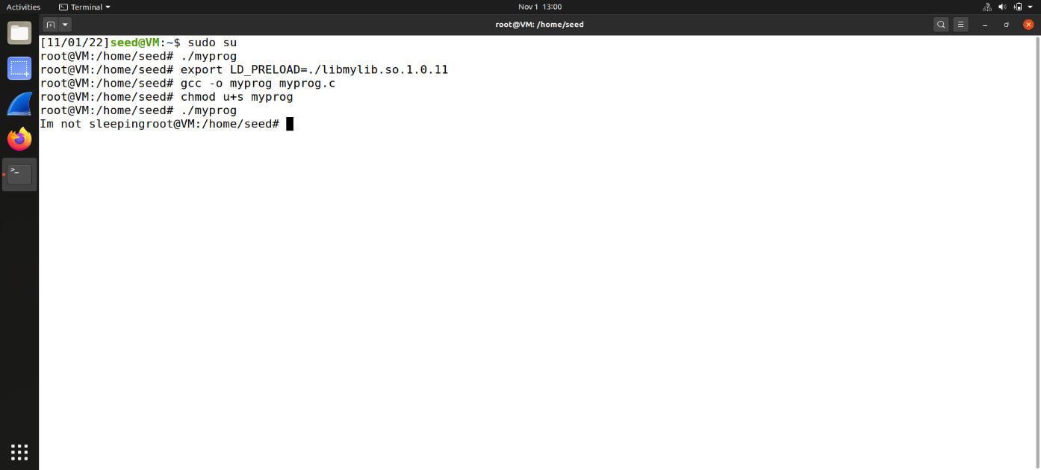

**- Make myprog a Set-UID user1 program (i.e., the owner is user1, which is another user ac- count), and run it as a different user (not-root user).**

•

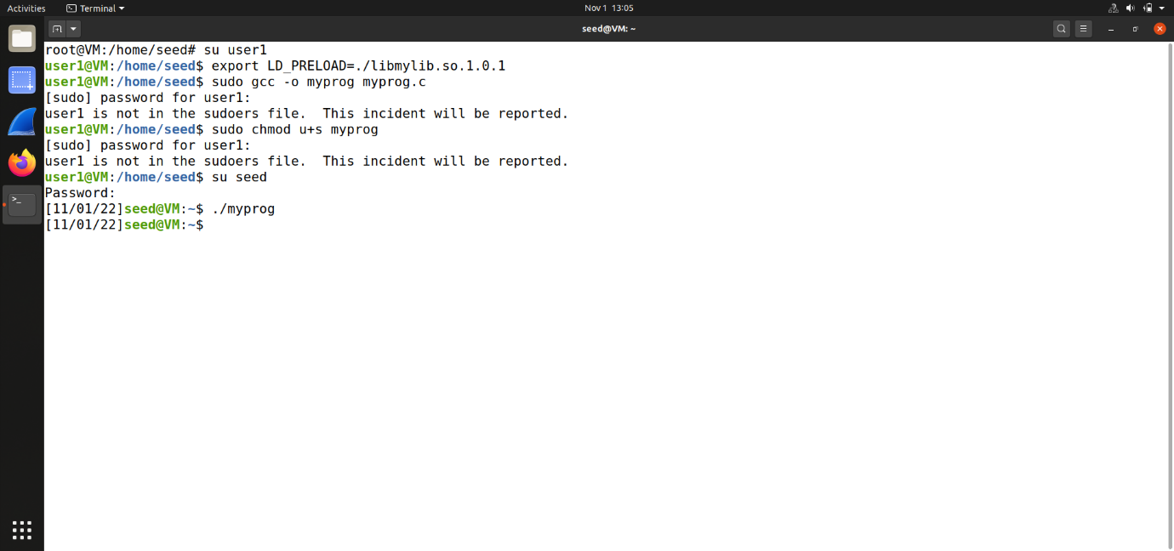

In this situation, it will not override sleep() function.

So when only when a user runs the program created by himself, LD_PRELOAD environment valiable can be used and sleep() function can be overrided.

## 7. Relinquishing privileges and cleanup.

**To be more secure, Set-UID programs usually call setuid() system call to permanently relin- quish their root privileges. However, sometimes, this is not enough. Compile the following program, and make the program a set-root-uid program. Run it in a normal user account, and describe what you have observed. Will the file /etc/zzz be modified? Please explain your observation**

#include <stdio.h>

#include <stdlib.h>

#include <sys/types.h>

#include <sys/stat.h>

#include <fcntl.h>

void main()

{

int fd;

// Assume that /etc/zzz is an important system file,

// and it is owned by root with permission 0644.

// Before running this program, you should creat

// the file /etc/zzz first.

fd = open("/etc/zzz", O_RDWR | O_APPEND);

if(fd == -1) {

printf("Cannot open /etc/zzz\n");

exit(0);

}

// Simulate the tasks conducted by the program

sleep(1);

// After the task, the root privileges are no longer needed,

// it’s time to relinquish the root privileges permanently.

setuid(getuid()); // getuid() returns the real uid

if(fork()) { // In the parent process

close(fd);

exit(0);

} else { // in the child process

//Now, assume that the child process is compromised, malicious

//attackers have injected the following statements

//into this process

write(fd, "Malicious Data", 14);

close(fd);

}

}

First we need to create a file named zzz which is owned by root in the /etc directory.

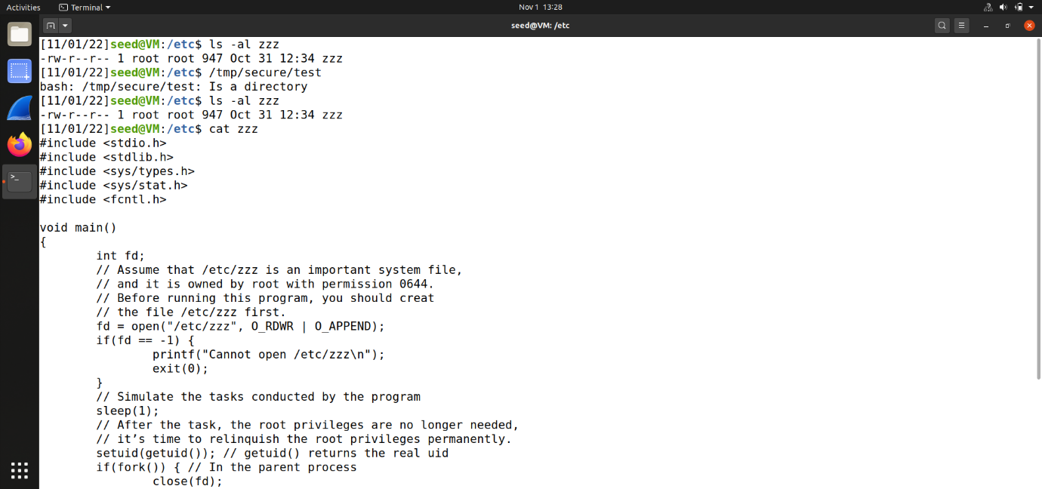

As we can see, the file has been modifid, the reason is file zzz is opened before set uid() . To avoid this problem we can move setuid(getuid()) to the front of open() function.